**MoonSwap mining process description:**

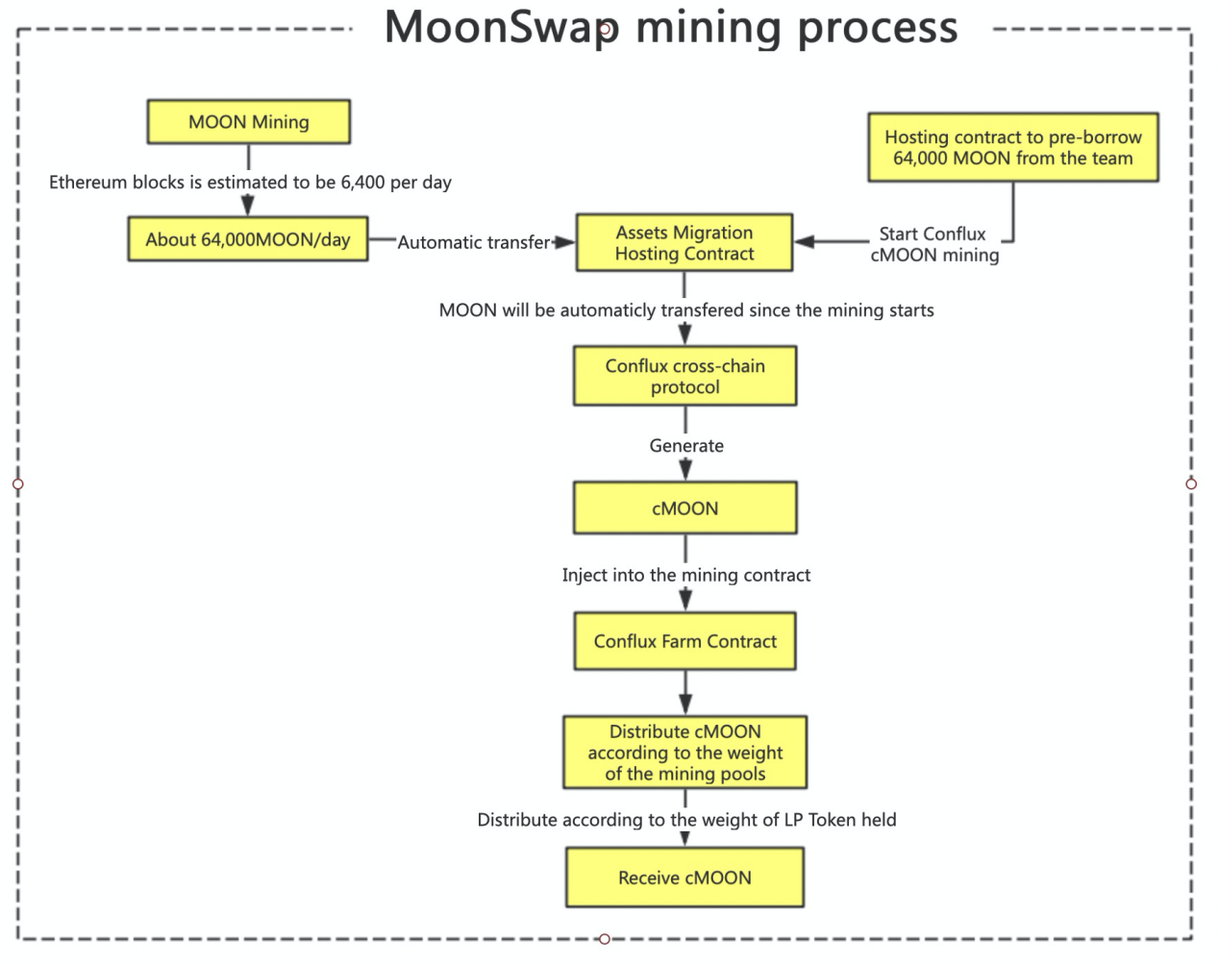

**Users migrate the assets on Ethereum to Conflux and add liquidity, they can still mine MOON every day. The specific mining process is described as follows:**

1. First of all, MOON on Ethereum have been output according to blocks.Based on the evaluation of the Ethereum block production speed in the past period of time, it is estimated that 64,000 MOON will be produced per day;(Will keep track of the Ethereum network and make dynamic adjustments, we will also issue an announcement before the adjustment and execute after the timelock takes effect)
2. The ERC20 asset MOON produced daily on the Ethereum will be automatically transferred to the asset migration custody contract, and the Conflux ERC777 asset cMOON will be generated through the Conflux cross-chain protocol;
3. Layer1 ERC20 asset MOON and Layer2 ERC777 asset cMOON complete one-to-one correspondence. Layer1 assets are managed by the Conflux cross-chain alliance, and Layer2 assets enter the Conflux for trading;
4. Due to the slow speed of the Ethereum network and the high gas cost, it is impossible to distribute cMOON across the chain in real time, so MoonSwap decided to advance 64,000 MOON from the team wallet to the assets migration hosting contract to guarantee the cMOON that should be produced in Conflux for at least one day.
5. After MoonSwap starts mining on Conflux, the MOON produced on Ethereum in a day will be automatically transferred to the asset migration hosting contract at 0:00 every day, and cMOON will be automatically generated through the Conflux cross-chain protocol and automatically injected into the Conflux Farm contract for cMOON distribution;
6. The output and distribution mechanism of cMOON is as follows:

The output of cMOON will be issued in seconds;

The cMOON produced will be distributed according to the weight of each mining pool;

The number of cMOON received by the user = the MLP held by the user in the mining pool / the total MLP in the mining pool * (the weight of the mining pool * 64000).

1. With an open attitude, MoonSwap announced several wallet addresses for community supervision and inquiries:

**Team wallet address on Ethereum:**

0x254ef048dbe047223856f1304b32a791914ab198

**Asset migration custody contract address on Ethereum:** 0xb61fFa6AC4dD2255A4b30C7A7Bfe4736EBA5ff50